# Creating NavMesh For Scene

AI is using **Unity’s Nav Mesh** for calculating the path. Therefore, you must bake and create navigation mesh for your scene first. Select your all static objects (including road too). And set them “**Static**”.

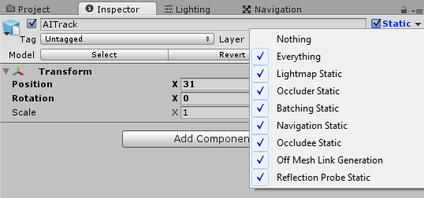

When all your static objects are marked as “**Static**”, then you can bake your navigation mesh. Open “**Navigation**” window from **Window 🡪 Navigation**.

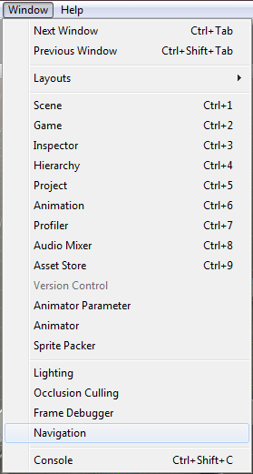

Default settings should be like this;

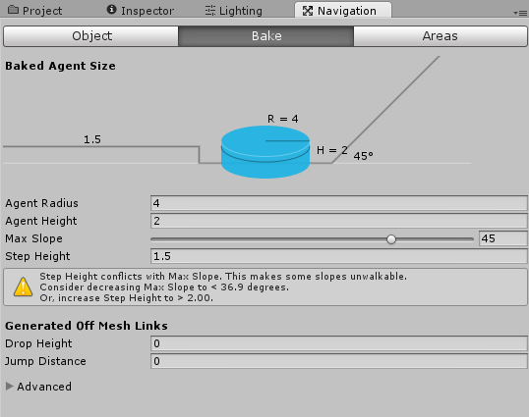

And then, click the bake button and bake your scene. Check your blue navigation mesh. AI will use this mesh for pathfinding. Should be like this;

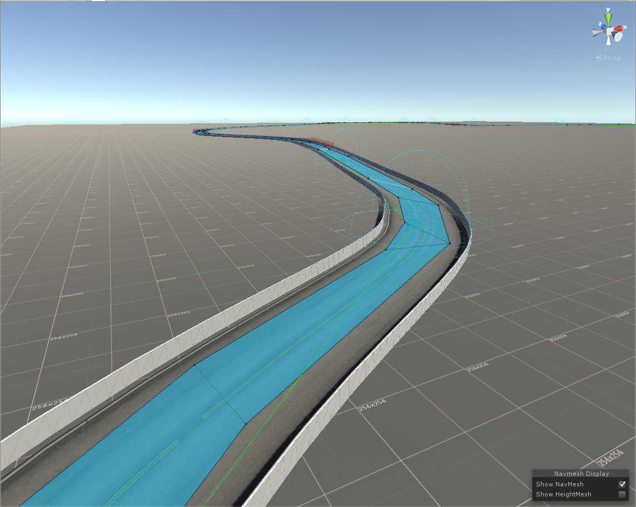

# Adding AI Controller To Vehicle

First, build and configurate your vehicle. Be sure it’s working properly. When everything works fine and results are as expected, you can add **RCC_AIController** to your vehicle by clicking “**Tools 🡪 BoneCracker Games 🡪 RCC 🡪 AI Controller 🡪 Add AI Controller To Vehicle**”.

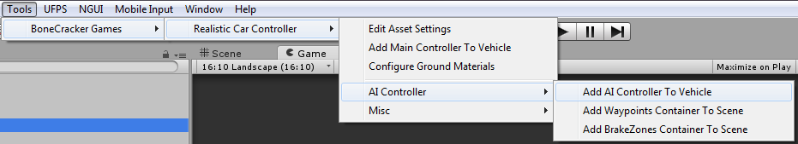

This will add “**RCC_AIController**” to the root of your vehicle;

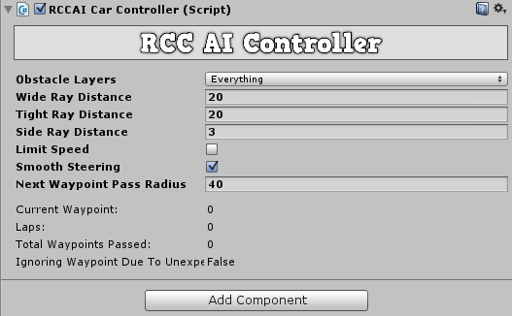

Vehicle will use “**Nav Mesh Agent**” for road path based on your waypoints, and will use raycasts for dynamic objects. If you have specified gameobjects to ignore raycasts, you can select specific layers from the obstale layers.

# Adding Waypoints Container To Scene

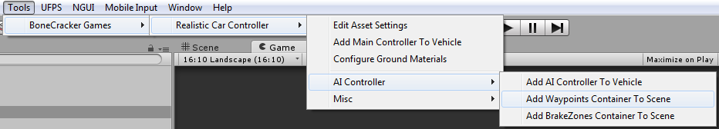

This will add “**RCC AI Waypoints Container**” to your scene. Simply hold Shift and left click on your road to create a new waypoints. Create your path with them;

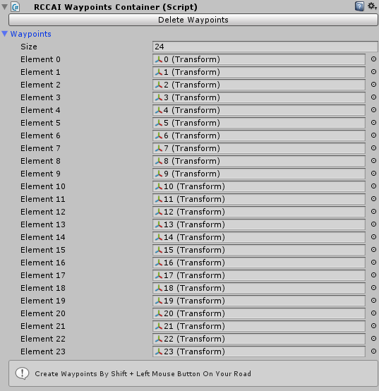

**Note**: Do not use CTRL + D for duplicating any waypoint.

Each waypoint has a target speed. Vehicle will adapt its speed to this target speed when radius.

**Note**: Be sure AI vehicle is close enough to the nav mesh. If it’s too far away from it, pathfinding won’t work.